MAZ Macrozoobenthos Benthic crabs

Blue swimmer ***Portunus pelagicus***

These crabs prefer muddy or sandy bottoms but can also be found on rubble, seagrass and seaweed. At dawn and dusk they feed most vigorously on shellfish, other crustaceans, worms and brittle-stars on the sea floor.

Calcareous material was found in the stomachs of over 50% of premoult and over

70% of recently-moulted crabs in the Peel–Harvey Estuary and contributed over 50% to the volume of the diets of the crabs representing those two shell states. This material, which comprised fragments of the shells of bivalve and gastropod molluscs, was more weathered and broken up in the stomach contents of recently-moulted than premoult crabs. Polychaetes, especially the nereid *Ceratonereis aequisetis* (Augener), and small bivalve molluscs, particularly the galeommatid *Arthritica semen* (Menke), were often consumed by crabs of these two shell states. Shell fragments of large decapods, especially *Portunus pelagicus* and *Ovalipes australiensis* (Stephenson and Rees), gammarid amphipods and small gastropods, mainly *Tatea* spp., which were each consumed by more than 10% of recently-moulted crabs and contributed 9.4, 3.4 and 2.6% to the dietary volume of these crabs, respectively, were never found in the stomachs of premoult crabs (Table 1). Small bivalves, represented almost exclusively by *A*. *semen*, and polychaetes, especially *C*. *aequisetis*, were the dietary categories most frequently consumed by far by intermoult *P*. *pelagicus* in the Peel–Harvey Estuary, each being found in ca. 47% of stomachs and contributing 20.9 and 25.1% to the total dietary volume, respectively (Table 1). Gammarid amphipods were consumed by nearly one third of intermoult crabs and comprised nearly 20% of their dietary volume. No other category contributed more than 7% to the total dietary volume (Table 1). In recently-moulted crabs in the Peel–Harvey Estuary, calcareous material contributed between 47 and 55% to the total dietary volume of each of the four size classes in which the carapace widths lay between 30 and 159 mm (Fig. 1). Although crabs, 90 mm CW also consumed considerable amounts of small bivalves, i.e. ca. 30%, this category made only a small contribution to the diets of crabs .120 mm CW. In contrast, the contributions made by both polychaetes and the shell fragments of large decapods increased progressively as crabs of this shell state increased in size (Fig. 1). The diets of small intermoult crabs in the Peel–Harvey Estuary, i.e., 30 mm, contained large amounts of crustaceans, such as amphipods and tanaids, particularly

*Tanais dulongii* Thomson, and also small bivalve molluscs, which collectively contributed just over 90% to the total volume of the diet (Fig. 1). As *P*. *pelagicus* increased in size, the contribution of amphipods and, to a lesser extent, that of tanaids, declined progressively, while particularly those of polychaetes and teleosts (*Favonigobius lateralis* (Macleay)) and also small decapods (*Penaeus latisulcatus* Kishinouye) and calcareous and plant material increased.

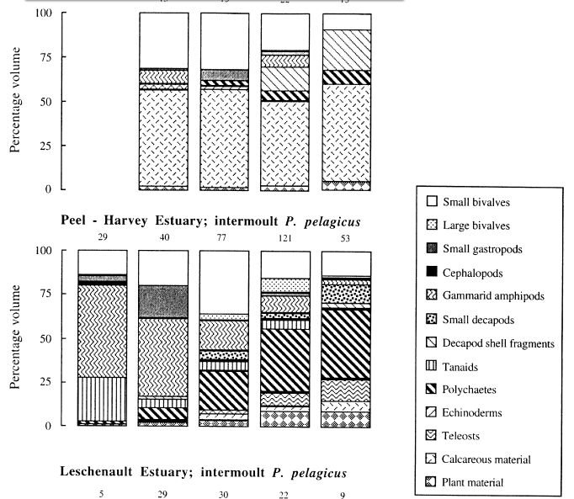

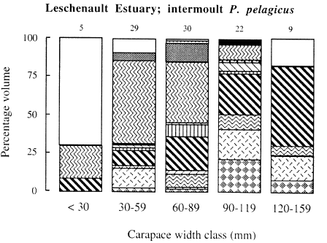

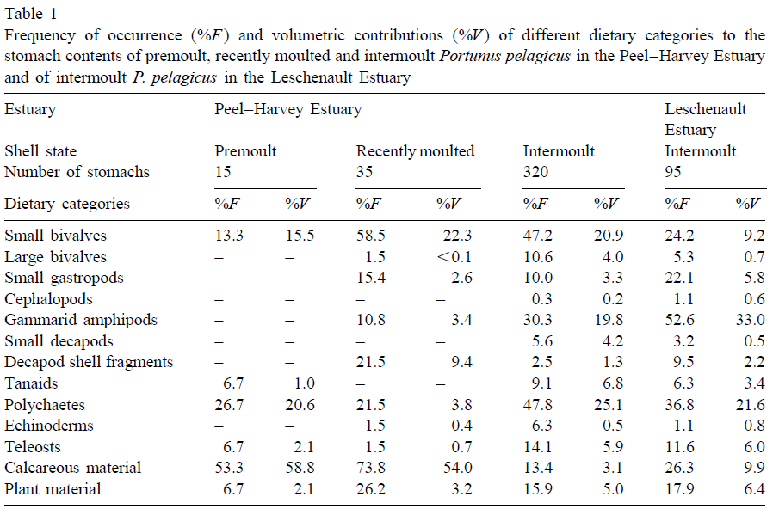

Slow-moving invertebrate species, in particular

molluscs (31.6% of the volume of foregut contents) and polychaetes (16.1% of volume), were the major

dietary items of ***P.pelagicus;*** however, the crabs also consumed lesser quantities of seagrass (10.2% of

volume). large carnivorous decapods are known to be key members of macrobenthic

communities, in some areas controlling the distribution and abundance of

epifaunal and infaunal prey (Ebling et al., 1964; Muntz et al., 1965; Viistein, 1977;

Elner & Raffaelli, 1980; Blundon & Kennedy, 1982; Jensen &Jensen, 1985). The diets of crabs collected from the debris and ***Amphibolis*** habitats at Cliff Head were

similar, both being dominated by the gastropod ***Cuntharidus lepidus*** (Phillipi) and, to a

lesser extent, seagrasses (Table II). Crabs sampled in the debris habitat in September

and December nevertheless ingested large quantities of sand with the food organisms.

The major items in the foreguts of crabs foraging in the unvegetated habitat were

infaunal species of polychaete and bivalve, and crustacean exuviae.

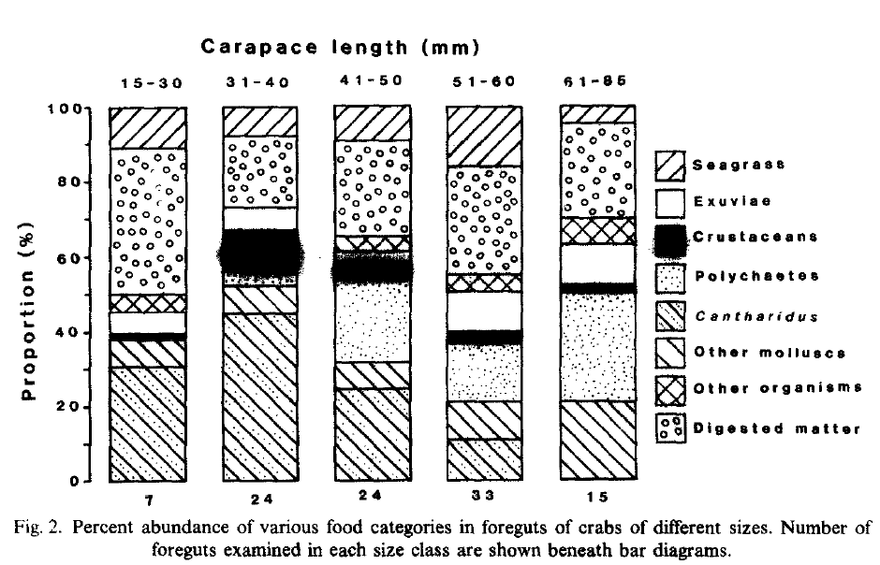

The diet of ***P. pelagicus*** was similar in several respects to the diet of the other large

30 G.J. EDGAR decapod which fed in the same area, ***P. Cygnus.*** Both species were opportunistic omnivores with preferences for slow-moving animal prey. They also both captured similar-sized prey (Fig 3 cf. Fig. 6 in Edgar, 1990b) and consumed similar organisms when feeding in the ***Amphibolis*** and debris habitats. The wide-ranging foraging strategy of ***P. pelagicus*** is also typical of other portunid crabs, all the studied species of which are reported to have mixed diets of molluscs, crustaceans and polychaetes similar to ***P. pelagicus (e.g., Carcinus maenas;*** Ropes, 1968; ***Scylla serrata:*** Hill, 1976; Collinectes ***spp. :*** Paul, 1981; ***Ovalipes catharus*** Wear & Haddon, 1987). Many portunids also consume small quantities of macrophytes, with only one species, ***Liocarcinus puber,*** having been found with a predominance of plant material in its gut (Choy, 1986). Other families of crabs are more likely to be “pickers” and to ingest larger quantities of plant material and detritus and lesser amounts of animal material than portunids. Watson et al. (1984), for example, did not list as predominantly carnivorous any of eight seagrass-associated crab species belonging to

five nonportunid families.

Hermit crabs: The following phyla were observed in the stomach contents: Crustacea (amphipods, copepods, isopods, body parts of larger unidentified Crustacea), Annelida

(polychaetes), Mollusca (bivalves, gastropods), Cnidaria (hydroids), Echinodermata (echinoids and holothurians), Bryozoa, Sarcomastigophora (foraminiferans). Also observed

were eggs of unknown origin (in **3** stomachs) and a single fish scale. both species the most common phyla were Crustacea, Annelida and Mollusca.

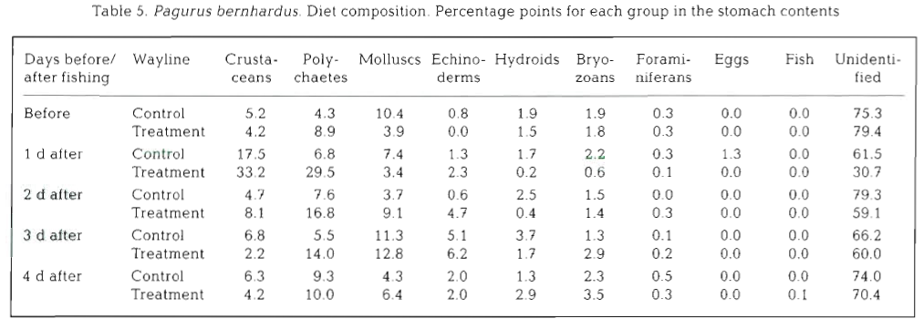

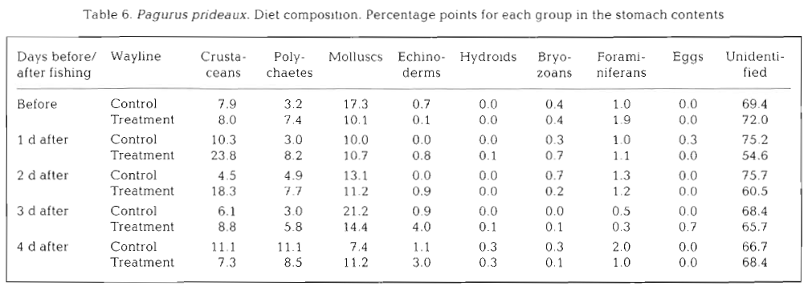

**Predatory crabs Romaleon polyodon and Cancer plebejus** : From the ten crabs collected during the directed sampling only three animals had some stomach content, consisting in shell fragments of the razor clam Tagelus dombeii and remains of small, unidentified crustaceans.

**Porcelain Crab** *Petrolisthes galathinus* Porcelain crabs likely consume algae, zooplankton, detritus, and juvenile invertebrates;

**Blue crabs Callinectes sapidus**: The gut contents of the crabs revealed that small juvenile blue crabs (540mm CW) are opportunistic feeders, like their larger conspecifics (Laughlin 1982 Hines et al. 1990; Mansour and Lipcius 1991; Mansour 1992). This can be seen clearly in the wide diversity of taxa found in their guts. The large percentage of clams, polychaetes, and other crustaceans is in accord with previous studies on adult blue crabs in the system (Hines et al. 1990; Mansour 1992), although relative percentages of the various items differed for the smaller juvenile crabs. We were able to detect a dietary preference for polychaetes and sometimes for clams, but avoidance of amphipods. The main difference in the gut contents of the small juvenile crabs examined here, relative to larger juveniles and adults reported previously in the literature (Mansour 1990; Hines et al. 1987), is that generally there was a larger percentage of polychaetes, and little evidence for cannibalism of conspecifics.

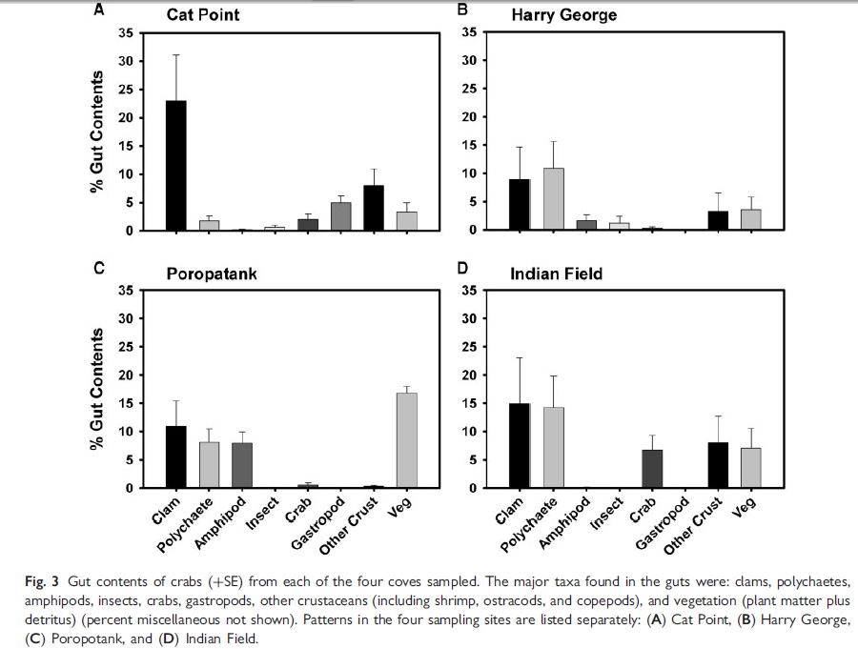

*Crangon* sp Twenty different prey types were identified visually in the proventricular contents of *Crangon*. The most common, frequently occurring, prey included detrital

material, crustacean exoskeleton pieces, nereid polychaete setae and jaws, and shreds of algae. Meiofauna were found in the guts of only 12 Crangon out of 172 examined visually. Taxa ingested included foraminifera, nematodes, harpacticoid copepods, and ostracods. Six of the 12 Crangon containing meiofauna were very small, only 4 mm TL. The other six ranged between 14 and 40 mm TL and contained fewer meiofauna per individual than the smaller Crangon. One of the 4 mm TL Crangon contained 12 harpacticoid copepods and 1 ostracod, and another 4 mm TL animal contained 10 ostracods and two harpacticoids. An 18 mm TL Crangon contained 13 ostracods.

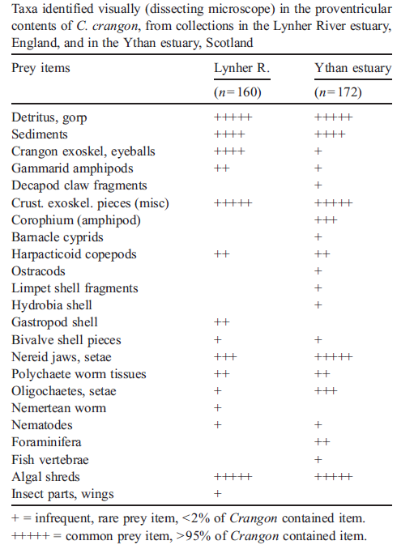

|  |  |
| --- | --- |
| **prey item** | **probability of consuming** |
| bivalve BFF | 0.3 |
| gastropods BG | 0.3 |
| polychaetes BC | 0.3 |
| crabs MAZ | 0.1 |
| small fish FDT | 0.05 |
| small fish FSR | 0.05 |
| seagrass SGR | 0.05 |
| algae MA | 0.05 |
| detritus DC | 0.1 |
| BAC | 0.5 |
| DR | 0.5 |
| DL | 0.5 |
| ZME | 0.2 |
| BO meiobenthos | 0.1 |

Reference

S. de Lestang, M.E. Platell, I.C. Potter 2000.[Dietary composition of the blue swimmer crab Portunus pelagicus L. Does it vary with body size and shell state and between estuaries?](http://apps.webofknowledge.com/full_record.do?product=UA&search_mode=GeneralSearch&qid=1&SID=S1VlJHC1kMfXLjNrrkr&page=1&doc=7)  Journal of Experimental Marine Biology and Ecology 246, 241–257

Ramsay, K., Kaiser, M.J., Hughes, R.N. 1996. Changes in hermit crab feeding patterns in response to trawling disturbance. MEPS, 144, 63-72

Aldo S. Pacheco, Martin Thiel, Roberto A. Uribe, Leonardo Campos, Jose M. Riascos 2013 Effects of sympatric predatory crabs Romaleon polyodon and Cancer plebejus (Decapoda, Brachyura, Cancridae) on sublittoral macrobenthic communities. Journal of Experimental Marine Biology and Ecology 443, 147-154

Kimberly A. Mcglaun and Kim Withers 2012. Metabolism, Consumption Rates, and Scope for Growth of Porcelain Crab (Petrolisthes galathinus) Gulf of Mexico Science, 2012(1–2), pp. 1–6

Rochelle D. Seitz, Kathleen E. Knick and Miranda Westphal 2011. Diet Selectivity of Juvenile Blue Crabs (*Callinectes sapidus*) in Chesapeake Bay Integrative and Comparative Biology, volume 51, number 4, pp. 598–607

Robert J. Feller Weak meiofaunal trophic linkages in *Crangon crangon* and *Carcinus maenus* Journal of Experimental Marine Biology and Ecology 330 (2006) 274–283